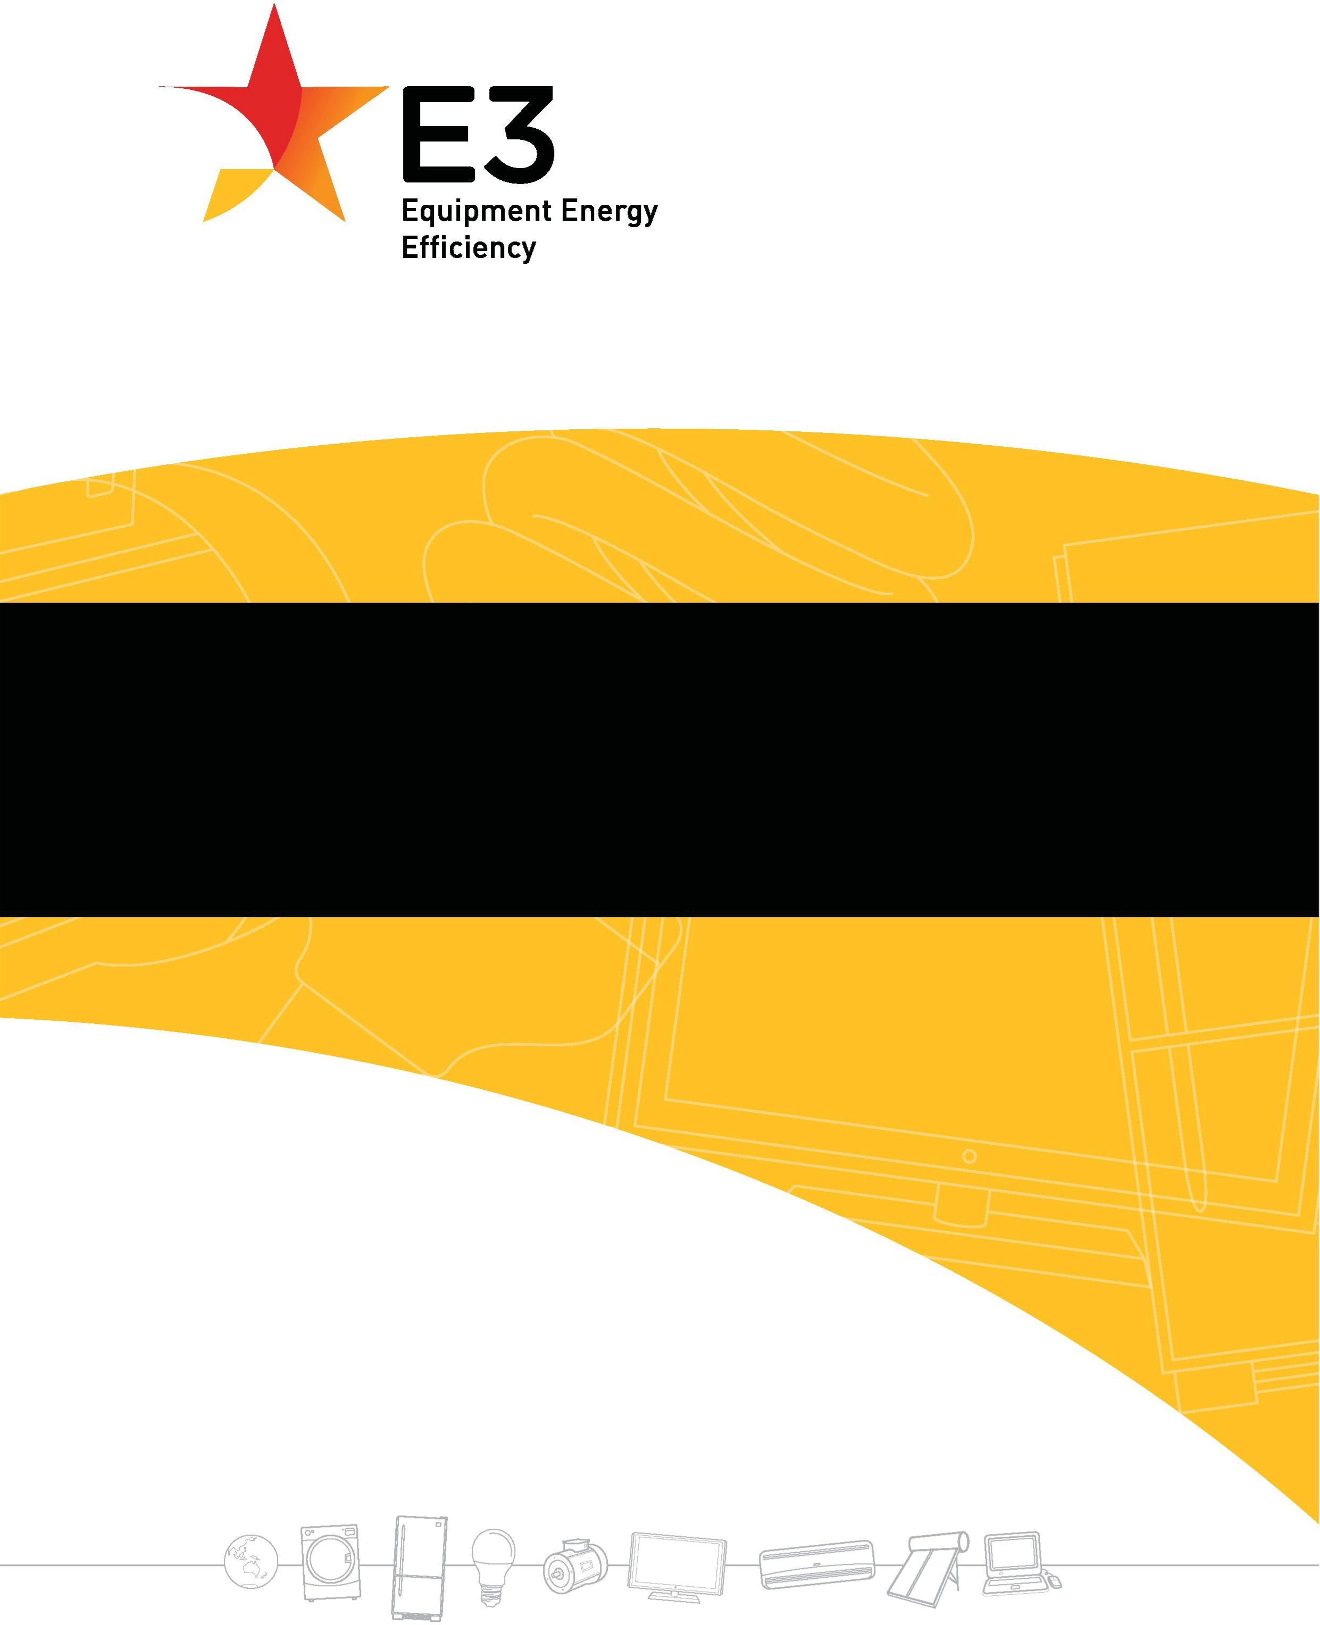

Public consultation paper

Investigating future regulatory options for lighting products
December 2022

This work is licensed under the Creative Commons Attribution 3.0 Australia Licence. To view a copy of this license, visit the creative commons website.
Content contained herein should be attributed to ‘Public Consultation Paper: Investigating future regulatory options for lighting products’, Australian Government Department of Climate Change, Energy, the Environment and Water 2022.
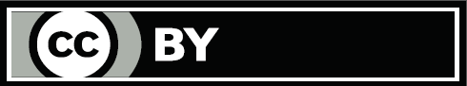

© Australian Government Department of Climate Change, Energy, the Environment and Water.
The material in this publication is provided for general information only. While reasonable efforts have been made to ensure that the contents of this publication are factually correct, E3 does not accept responsibility for the accuracy or completeness of the content. It does not constitute legal or other professional advice. E3 disclaims liability, to the extent permitted by law,
for any liabilities, losses, damages and costs arising directly or indirectly from any reliance on the information contained in this publication. Before any action or decision is taken on the basis of this material the reader should obtain appropriate independent professional advice.
This document is available at http://www.energyrating.gov.au and the Department of Climate Change, Energy, the Environment and Water’s consultation hub.

- Overview 2
PART 1
Overview of Proposed Changes to Lighting 3
- Context for Proposed Changes to Lighting 3
- What are the changes to Lighting regulations? 3
- Lighting Has Changed and so Has the Need for Government Action 4
- Lighting in Australia – Import data and state of the market snapshot 8
- About the Lighting Legislation 9
- What we will do with your feedback 9
- How you can provide your feedback 10
- What have we heard through consultation undertaken to date? 10
- When would the regulations apply? 10
- Why the changes to lighting are being pursued 11
PART 2
Technical Details of the Lighting Determinations 12
- Introduction to Part 2 12
- Standards Considered 12
- Incandescent Lamps 13
- LED Lamps 14
ATTACHMENTS
Attachment A: Incandescent Lamps: Differences in Proposed Determination and 2016 Determination 17
Attachment B: European Lighting Efficiency Regulation 22
Attachment C: Diagram of cap types in scope for incandescent lamps 23
Attachment D: Diagrams of cap types LED in scope for LED lamps 26
Attachment E: GEMS level requirements for Incandescent lamps 29
Attachment F: Ecodesign requirements—energy efficiency 31
APPENDICES
Appendix A: Background on the Greenhouse and Energy Minimum Standards Act 2012 35
Appendix B: Caveats on ABS lighting 36

Overview
This consultation paper outlines what the Australian and New Zealand Governments are considering to improve the energy efficiency of lighting in homes, commercial and industrial premises.
These changes would help alleviate cost of living pressures for consumers by reducing household energy use and lowering ongoing costs of lighting especially in the home. Introduction of these changes would also allow the lighting industry to lock in their contribution toward Australia’s target to reduce emissions by 43 per cent by 2030 and reach net zero by 2050.
The Commonwealth, state and territory governments are proposing to continue phasing out incandescent and halogen lamps and introduce new minimum energy performance standards (MEPS) and labelling requirements for Light Emitting Diode (LED) lamps.
This consultation is focused on the Australian legislative instrument (draft determination). Amendments to the
New Zealand legislative instrument, Energy Efficiency (Energy Using Products) Regulation 2002, will be completed in a separate consultation in the future.

Why we are consulting?
We want to let you know about the proposed changes to lighting requirements and hear how these changes may affect you. Your responses will help us to better understand any issues that may require further consideration before the policy is settled and implemented. Your views will help ensure the Government’s actions deliver consumer and industry benefits.
To assist you, this discussion paper is structured with a focus on two broad audiences as shown in Figure 1.
If you have a general interest in lighting, for example if you are a homeowner, buyer, renter, landlord, builder or designer you should review Part 1. If you are interested in lighting technical detail, for example if you are a product certifier,
test laboratory, supplier, manufacturer, importer, wholesaler or retailer you should review part 2 as well.

Figure 1. Structure of the consultation paper and target audience

Homeowner, renter, landlord, builder or designer, lamp purchaser

PART 1

Product certifier, test laboratory, supplier, manufacturer, importer, wholesaler or retailer

PART 2

Overview of Proposed Changes to Lighting

Context for Proposed Changes to Lighting
The Australian and New Zealand governments collaborate through the Equipment Energy Efficiency (E3) program on minimum energy performance and labelling requirements for appliances and equipment. In Australia, the Greenhouse and Energy Minimum Standards (GEMS) Act 2012 contains provisions which allow MEPS to change over time to encourage greater efficiency, reducing energy use and delivering emissions savings. For further background on the GEMS Act and E3 refer to Appendix A.
It is anticipated the benefits of improvements in lighting energy efficiency will support the broader goals of demand side management under the National Energy Transformation Partnership. As governments work to deliver secure and affordable low-emission energy supply, there is a need to accelerate demand-side action to support an efficient, least-cost pathway through the energy transformation. The new National Energy Transformation Partnership was
established on 12 August 2022 by Commonwealth, state and territory Energy Ministers. This partnership is a framework for national alignment and cooperative action by governments to support the smooth transformation of Australia’s energy sector. One of the priority areas identified for cooperation is demand evolution and regional level scenario planning in the light of increasing electrification, and demand management opportunities including energy efficiency, distributed energy resources, electric vehicles and demand response.
Australia (and to a lesser extent, New Zealand) lags behind international counterparts on energy efficiency and performance. The Climate Change Performance Index, an independent monitoring tool presented at the annual UN Climate Change Conference, ranks Australia 54 and New Zealand 35 out of 64 countries for energy performance per capita. The EU has been progressively strengthening its energy efficiency targets to reduce costs and meet its 2030 emissions reduction goals and, in our region, similar action is being pursued by countries such as South Korea and Japan. The International Energy Agency (IEA) has made it clear that without early action on energy efficiency, the transition to net zero emissions will be more expensive and difficult. Energy efficiency policies will cut energy costs for households and businesses, reduce pressure on the energy system and help Australia and New Zealand meet our emissions reduction goals.

What are the Changes to Lighting Regulations?
The proposed changes are:
- Introducing MEPS for Light Emitting Diode (LED) lamps
  - Aligning closely with European Union lighting regulations: Commission Regulation (EU) 2019/20 and the relevant amendments of 2021/341, Laying down ecodesign requirements for light sources and separate control gears 2019 L 315/209.
  - will include photobiological safety requirements
- Further phasing out less efficient lighting technologies such as incandescent and halogen lamps. New Zealand will not be regulating incandescent and halogen lamps.

What will the Minimum Standards deliver and how?
In Australia, two new Determinations are proposed to:
- establish energy efficiency performance standards for LED lamps for Australia by enacting the Greenhouse and Energy Minimum Standards (LED Lamps) Determination 2023 and
- continue phase out of inefficient incandescent and halogen lamps where an equivalent replacement LED lamp is available by enacting the Greenhouse and Energy Minimum Standards (Incandescent Lamps for General Lighting Services) Determination 2023.
The new Determinations will help governments alleviate cost of living pressures for consumers by reducing household energy use and lowering the ongoing costs of lighting while ensuring new and improved quality lighting products are available.

The two new Determinations1 will allow the lighting industry to lock in their contribution toward Australia’s target of reducing emissions by 43% by 2030 and reaching net zero by 2050. The introduction of MEPS for LED lamps and the phase out of incandescent and halogen lamps is estimated2 to provide a large net benefit of $1.448 billion to 2030, save 8,777 Gigawatt-hours (GWh) of energy and 5.5 million tonnes (Mt) of emissions, cumulative to 2030. This would also provide savings in Australia on energy costs for consumers of $1.396 billion, and to businesses of $132 million by 2030.
More detail associated with government evaluation of options, including the full suite of costs and benefits considered by Ministers is available in the Decision Regulation Impact Statement: Lighting 2018 (DRIS).

Lighting Has Changed and so Has the Need for Government Action
MEPS were first used to improve lighting equipment energy efficiency in 2003. In 2009 Australia was among the first countries to announce the phase out of many incandescent and halogen lamps (globes or bulbs) to further improve energy efficiency requirements for lighting. This was implemented under the E3 program.
Individual lamps do not consume large quantities of electricity. However, the average Australian home has 37 lamps3. Lighting in homes consumes about 10% of the average household electricity budget (or about 7% of its energy use)4. The more efficient lamps usually have a slightly higher upfront cost, but the payback on a more expensive, but efficient lamp is generally within one year5.
For the commercial sector, lighting systems account for between 20–40 per cent of electricity end-use in Australia6
It is estimated that the incandescent lamp phase out (along with state-based energy efficiency obligations schemes) is saving around 2.4 terawatt-hours (TWh) of electricity each year (equivalent to the total annual electricity consumption of 400,000 homes7).
Compact fluorescent lamps (CFLs) have also been subject to MEPS in Australia since November 2009. Since then, many other countries have adopted regulations which emulate the Australian inefficient incandescent and halogen lamp phase out.
Many countries (approximately 61) have recognised MEPS as an effective measure to influence product energy performance and adopted (~289) voluntary or mandatory lighting related programs that expand MEPS to other lighting products. These include ~18 countries (or economies) with~ 23 LED lamp programs of which 11 are mandatory,
with others under development8.
The global lighting market has changed considerably, due to the introduction of light emitting diode (LED) lighting technology. The E3 program implemented a separate review and the report, Product Profile: Light Emitting Diodes (LEDs) was released in 2015.
The DRIS estimated that in 2018 around 80 million lamps were sold in Australia with an estimated installed stock of more than 400 million9. The industry has advised this data does not reflect the current state of lighting sales in Australia
- due to the long lifetime of LED lamps, annual lamp sales volumes continue to decline. LED lamps are now widely available in Australia, New Zealand and elsewhere, with prices continuing to decrease. Good quality LED lamps last 5 to 15 times longer than halogen lamps, and at most consume one-quarter (and more typically one eighth) of the energy to produce the same light output.10

- Determinations” is used here to refer to both the Australian and New Zealand requirements. New Zealand does not have Determinations but uses Regulations to set energy efficiency requirements. See the section on “About the Lighting Legislation” for more information.
- Decision RIS: Lighting 2018
- E3, Residential Lighting Report, prepared by Energy Efficient Strategies, 2016.
- Reference - https://www.yourhome.gov.au/energy/lighting
- Decision RIS: Lighting 2018
- Decision RIS: Lighting 2018
- www.energyrating.gov.au
- CLASP database
- Decision RIS: Lighting 2018
- Decision RIS: Lighting 2018

An evaluation of LED lamps available in the marketplace carried out in Europe and Australia (2018-2021) for the 3 LED lamp types proposed in the GEMS regulation indicates a wide variation in energy efficiency (for lamps this is known as efficacy, the amount of light produced per unit of electrical power consumed). The availability of poor performing and low quality LED lamps on the market risks a rejection or slower, less complete uptake by consumers of this technology as an effective, efficient alternative to halogen lamps. This is explained further below.
Noting these issues and the energy efficiency outcomes, the European Union has mandated MEPS via the Commission Regulation (EU) 2019/2020 covering eco-design requirements (which include health, safety and quality attributes) for LED lamps, control gear and LED luminaires. The EU EcoDesign regulations came into effect in September 2021.
Australia and New Zealand have agreed that our MEPS proposal will align with the EU regulations as it is acknowledged LED lamps in Australia and New Zealand are all imported and will be subject to international standards and regulatory requirements in other economies.
LEDs have achieved significant market penetration but there are LED lamps being supplied to the Australian market that have efficacy values 10 to 35 per cent below the proposed MEPS limit. This limit is now mandatory in Europe, implying lamps available here are not as efficient as those supplied in the EU.
If a regulatory regime is not in place, it allows lower performing (non EU MEPS compliant) lamps to be sold in Australia. There are two aspects to this:
- At present LED lamps are not covered by MEPS, therefore, any level of performance and any subjective claim is allowable. Buyer beware is the legal status for efficacy.
- Products claiming to be something they are not (eg, equivalent to a 60W incandescent) could be available on the market.
There have been concerns raised over the last decade about non-compliant product claims. This was highlighted by the 2015 Senate inquiry into non-conforming building products which examined the impact of non-conforming building products and possible improvements to regulatory frameworks. The government response to the Senate Economics References Committee’s final report was tabled on 23 April 2020.
The peak body for the lighting industry, the Lighting Council of Australia during 2022 asked its members to report instances of non-compliance as a concern and report noncompliant products to authorities.
The Electrical Equipment Safety Scheme (EESS) implemented its highest level of safety requirements in 2018 over concerns with safety of mains voltage LED lamps. The industry has advised the introduction of these safety standards has increased the overall quality of LEDs in Australia.
Australia through the E3 program has been and will continue to be proactive in monitoring the performance of a wide variety of lighting products. Sample measurements have been carried out in Europe and Australia (2018-2021) for the
3 LED lamp types proposed in the GEMS regulation. These show the LED lamp performance (efficacy versus light output) against the proposed MEPS limit.
The charts and tables below show a number of lamps including some available in Australia, with an efficacy that is ~10 to 35 per cent below the proposed limit. These lamps are or could be supplied into the Australian or New Zealand markets.
Figures 2, 3 and 4 illustrate the results of these measurements, indicating some lamps with efficacy ~10 to
35 per cent below the proposed limit, which may end up in Australian and New Zealand market, if there is no proper regulatory regime.

Figure 2: Non-directional Mains voltage LED Lamp (single capped) test results compared with proposed MEPS limit

PRODUCTS SAMPLED FROM MARKETS IN EUROPE/AUST (2018–2021) | TESTED | BELOW MEPS | %
MV Non-Dir lamp | 296 | 38 | 13
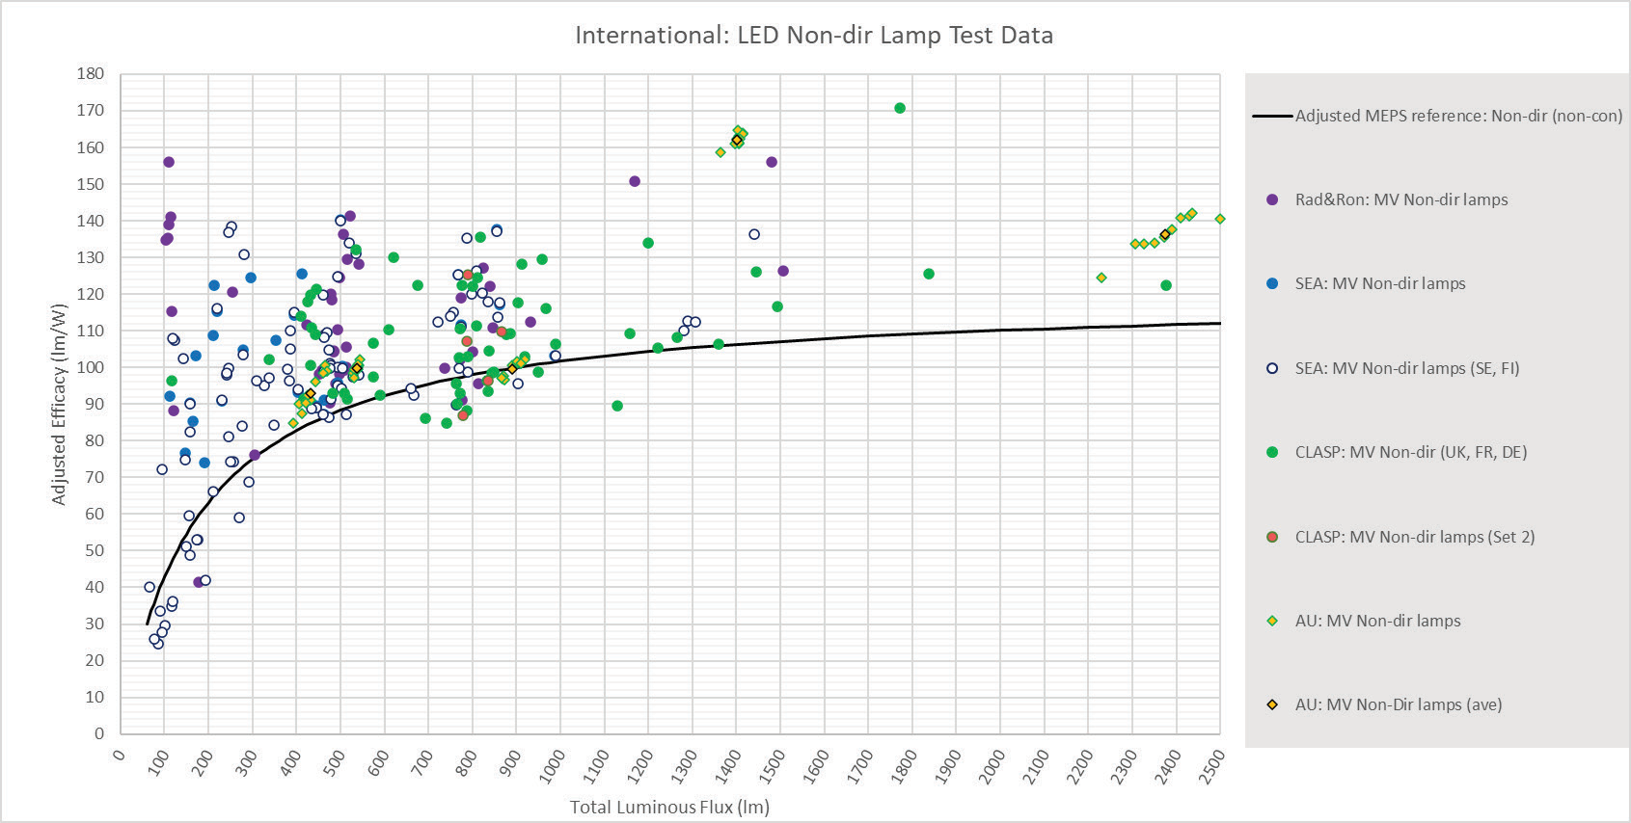

Figure 3. Directional LED Lamps (single capped) test results compared with proposed MEPS limit

PRODUCTS SAMPLED FROM MARKETS IN EUROPE (2018–2021) | TESTED | BELOW MEPS | %
Dir lamp | 76 | 8 | 11
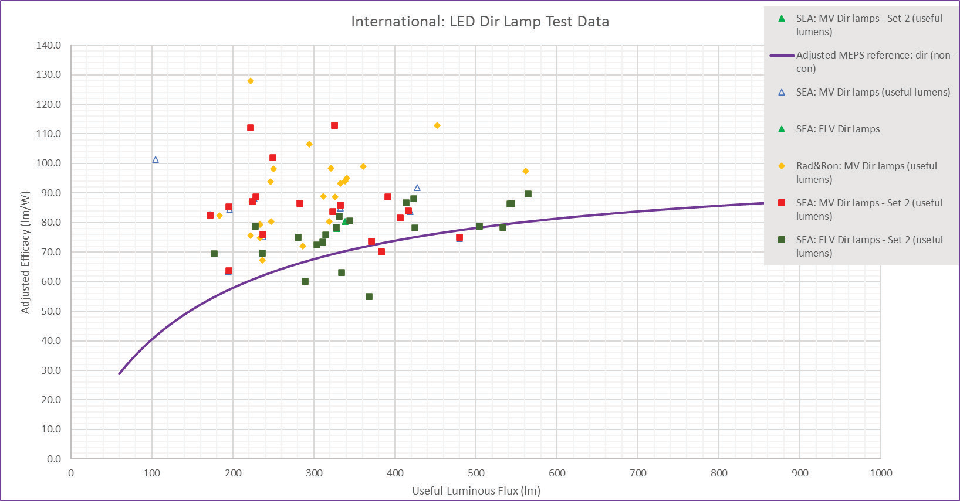

Figure 4. Non-directional mains voltage linear LED lamps (double capped) - [Fluorescent tube replacement] compared with proposed MEPS limit

PRODUCTS SAMPLED FROM MARKETS IN EUROPE/AUST (2018–2021) | TESTED | BELOW MEPS | %
MV Non-Dir linear lamp | 18 | 7 | 39
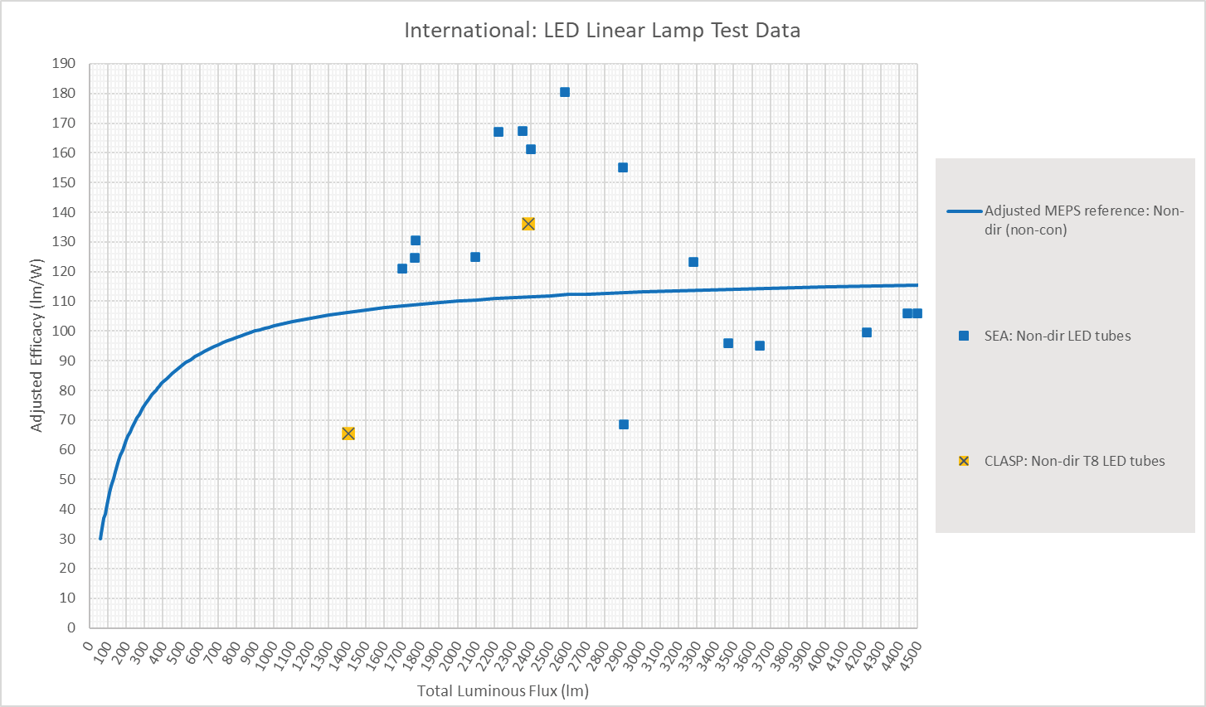
The DRIS identified that MEPS on LED lamps alone using the above limits will deliver modest energy efficiency savings for households, as it is a highly efficient new technology. The major efficiency gains would be achieved through phase out of halogens and incandescent lamps, which continue to comprise a significant portion of the lamp market. In 2020, over 10 million incandescent and halogen lights were imported into Australia. Australia has an opportunity to keep pace with international standards, through implementing MEPS for LEDs. The International Energy Agency (IEA) Solid State Lighting (SSL) Annex, Task 6 for LED lamps recommends a minimum LED efficacy that is slightly above those presented here11.
For an 800 lumen output lamp (equal to a 60W incandescent or 42 W halogen) the IEA advises that for a non-directional lamp 70-80 per cent of lamps can easily achieve 105 lm/W, ie 7 per cent higher than the proposed limit. MEPS and energy rating label requirements are reviewed periodically to ensure they keep up with advances in technology.
As a result, from time to time there may be new or revised MEPS or energy label requirements introduced for regulated products.
The IEA data 12show that in the absence of minimum efficacy requirements (2019 market survey and test data), the spread of lamp efficacy extends from well below both the IEA Tier 1 projection of 105 lm/W (and proposed Australian/New Zealand MEPS) to well above the IEA Tier 2 projection of 150 lm/W. 13 At the IEA Tier 1 efficacy
MEPS would remove approximately 20% of the worst performing LED lamps from the presently unregulated market. The proposed limit will remove less, but as in Figures 2, 3 and 4 above, substantial improvements can still be made.

- International Energy Agency (IEA) Solid State Lighting (SSL) Annex Task 6. Supplementary Technical Information regarding the Quality and Performance Requirements, LED Lighting products, Energy Efficient End-use Equipment (4E), Oct 2022, Page 19
- The IEA evaluated data from 61,457 LED lamps, between 2009 and 2020 from 6 countries including 3,196 from Australia. Additional data to 2022 from 4 countries was also evaluated but not included in the report.
- International Energy Agency (IEA) Solid State Lighting (SSL), Annex Task 6. Quality and Performance Requirements. LED Lighting products.
Energy Efficient End-use Equipment (4E) Oct 2022. Page 1

Lighting in Australia – Import data and state of the market snapshot
The Department purchases lighting product import data from the Australian Bureau of Statistics (ABS) in order to assist our understanding of volumes of products both are currently regulated or proposed to be regulated under the GEMS Act. This provides up to date information on lighting trends, noting the data underpinning the Decision RIS is aging and doesn’t well reflect the rapid changes in technology in the lighting market. Figure 5 shows lighting product import data, focusing on product types mostly associated with residential lighting. Some caveats associated with the ABS import data are detailed in Appendix B.
Industry has also advised that consumers have moved voluntarily to LED lamps, and LEDs have dominated the market since 2017. This is supported by figure 5 which shows the LED lamp imports growing over the last few years.

Figure 5 Australian Lamp Imports
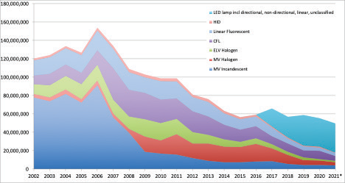
[lamp types considered are, LED lamp – Light Emitting Diode lamp, HID lamp – High Intensity Discharge lamp, CFL – Compact Fluorescent Lamp, ELV Halogen – Extra Low Voltage Halogen, M Halogen – Medium Voltage Halogen, MV Incandescent – Medium Voltage Halogen]

Since 2016 the proportion of incandescent and halogen lamp imports to Australia has reduced while that of LED lamps has increased. However, of the total of 55 million lamps imported to Australia in 2020, incandescent and halogen lamps still comprised over 10 million units thus supporting the need for government action to phase out inefficient incandescent and halogen lamps, for which LED alternatives are available.
All LED lamps used in Australia and New Zealand are imported. Figure 5 shows overall lamp imports in broad product technology categories. While imports of older inefficient technologies have declined, commencing with the phase-out and state government programs in 2008-09, the rate of decline has slowed during the last 3-4 years.
Compact Fluorescent Lamps (CFL) have also remained a relatively consistent portion since 2017 but in 2022/23 it is expected these will be at or nearing the end of life and could be replaced by LEDs. CFLs will also be phased out globally in 2025 by the Minamata Convention on Mercury.
Table 1 shows lamp import figures from 2015 to June 2021. LED lamp import figures include a significant unclassified portion, making it impractical to assign to subcategories. Table 2 compares ABS 2020 lamp import figures to imports predicted by the market model used for the 2018 lighting Regulation Impact Statement (it is not possible to compare LED numbers due to import category uncertainty).

Table 1 Lamp Imports - 2015-June 2021

 | 2015 | 2016 | 2017 | 2018 | 2019 | 2020 | 2021 (JAN-JUN)
MV Incandescent | 7,452,238 | 8,286,438 | 8,667,779 | 5,518,582 | 4,390,148 | 4,397,288 | 1,980,272
MV Halogen | 16,708,774 | 19,075,435 | 13,931,059 | 9,902,614 | 5,557,405 | 5,065,695 | 1,863,418
ELV Halogen | 5,519,682 | 6,153,274 | 4,351,157 | 3,366,077 | 2,683,694 | 1,390,574 | 704,818
CFL | 13,180,852 | 13,337,309 | 8,797,375 | 9,104,593 | 7,670,457 | 9,087,465 | 2,618,460
LED lamp incl. directional,  non-directional, linear, unclassified |  |  | 20,777,871 | 23,161,240 | 33,836,672 | 31,209,986 | 15,870,553
Linear Fluorescent | 11,491,790 | 10,360,364 | 9,420,379 | 5,452,557 | 4,401,702 | 3,545,200 | 1,611,346
HID | 2,178,514 | 2,072,869 | 1,362,832 | 1,087,404 | 762,584 | 979,006 | 299,733
Total | 56,531,850 | 59,285,689 | 67,308,452 | 57,593,067 | 59,302,662 | 55,675,214 | 24,948,600

About the Lighting Legislation
Your feedback is sought on the draft regulation(s) prior to consideration by Australian, State, and Territory governments:
- Greenhouse and Energy Minimum Standards (Incandescent Lamps for General Lighting Services) Determination 2023; and the
- Greenhouse and Energy Minimum Standards (LED Lamps) Determination 2023
In Australia, the Greenhouse and Energy Minimum Standards Act 2012 regulates the energy efficiency of over 20 types of appliances and equipment. The proposed Greenhouse and Energy Minimum Standards (Incandescent Lamps for General Lighting Services) Determination 2023, would widen the scope of the current regulations for incandescent and halogen lamps, effectively removing a wider range of these lamps from the market.
Until now there has been no regulation of LED lamps, therefore the introduction of the proposed Greenhouse and Energy Minimum Standards (LED Lamps) Determination 2023, would introduce a new product under the GEMS framework.
These new requirements are proposed to be introduced in tandem so their effects complement one another. Specifically, as inefficient lamps are phased out by one determination, the other will improve the energy efficiency of remaining alternative lighting products on the market, to maintain a high performance standards for the benefit of consumers.
In New Zealand, the Energy Efficiency (Energy Using Products) Regulations 2002 regulates the energy efficiency of 20 types of appliances and equipment. New Zealand does not have regulations for the efficiency of LED lamps.
Therefore, the energy efficiency of these products is currently unregulated. New Zealand intends to adopt functionally similar energy efficiency regulations for LED lamps in line with the proposed Australian Determination. Amending the regulations in New Zealand will be subject to a separate process, which will include consultation with industry. New Zealand will not be regulating incandescent and halogen lamps.

What we will do with your feedback
The information you provide will guide and inform the final decisions about the changes to lighting. The high level findings from written submissions (unless requested not to be made public) will be published on the Consultation Hub webpage. In addition to this consultation process, targeted market research will be conducted to ensure we understand the range of energy efficiency and quality of lighting products that are currently for sale.
Following both of these consultation processes, Government officials in Australia will consider the feedback and make appropriate adjustments prior to the changes being considered by Energy Ministers in 2023. Energy Ministers will be presented with stakeholder views to inform their deliberations. A transition period of 12 months is also proposed to support industry to transition and prepare for the regulatory changes.

How you can provide your feedback
There are multiple ways to have your say. You can provide a general written submission on the proposed policy changes or you can provide a response prompted by the questions in part 2 of this consultation paper to guide your submission or a combination of both.

What have we heard through consultation undertaken to date?
Extensive consultation has been undertaken to develop the draft suite of regulations both in Australia and New Zealand. In 2016 a Consultation Regulatory Impact Statement was released which set out the case for government intervention and the associated costs and benefits.
Energy Ministers considered the valuable stakeholder feedback and costs and benefits for industry and the community in the Decision Regulation Impact Statement in 2018.
Since the decision was made by Energy Ministers in 2018, the Australian and New Zealand Government agencies tasked with the introduction of new minimum standards have consulted further on the technical details of the proposed MEPS for LEDs. A technical working group was established in 2020 to ensure the draft regulations are streamlined and deliver the intended policy outcome. The LED Technical Working Group comprises key industry and stakeholders including the Australian and New Zealand lighting peak bodies, global and local lighting suppliers, energy network, consumer and lighting design bodies. This group has actively helped to shape the draft regulations.
Significant steps have been taken by governments to streamline the regulatory approach and reduce the administrative burden on industry. This includes:
- Alignment with the European Union eco-design requirements noting the LED lamps are all imported and many products are already demonstrating compliance with those standards (see Section 13.3 for further information).
- Registration of a product or family of products which is required under the GEMS Act, will not require the upload of a test report for the LED lamp
- A generous family definition has been proposed to help reduce the registration fees component.

When would the regulations apply?
The Australian Government recognises the effects the COVID-19 pandemic has had on the industry, including shutdowns, physical distancing restrictions, and subsequent flow-on effects.
Comments and views on whether the proposed commencement date allows the industry sufficient time to comply with the requirements, are welcomed. It is proposed to include a 12 month transition period from when the Determinations are made, to when they come into effect to allow the industry to adjust to new regulations.
Lamps that were manufactured in, or imported into, Australia prior to the proposed commencement date of (to be determined) and which do not meet the mandated MEPS levels, would be covered by the grandfathering arrangements of the GEMS Act.
This means any remaining non-compliant stock could be supplied to the market until it was exhausted, but no additional such stocks could be manufactured in or imported into Australia from the commencement date. From the commencement date of (to be determined), lamps which comply with the new MEPS requirements would be required to be registered before being supplied, regardless of when they were imported or manufactured. The Department is considering ways it can assist suppliers in managing this transition and would welcome comments and suggestions on this.
In New Zealand, the Energy Efficiency (Energy Using Products) Regulations 2002 will need to be amended before the requirements for LEDs come into force. Public consultation on proposed amendments to the New Zealand regulations will be undertaken in a separate consultation.
Following any amendment to the Regulations, a minimum of 6 months’ notice will be provided via the Gazette before the enforcement date.

Why the changes to lighting are being pursued
In April 2018, Energy Ministers agreed to further improve lighting energy efficiency regulation by phasing out inefficient halogen lamps (light bulbs) in Australia and introducing minimum standards for LED lamps in Australia and New Zealand in line with European Union (EU) standards.
Energy Ministers also agreed to align the timing of Australia’s LED regulation with the EU regulatory process.
As finalisation of the EU regulation was later delayed by 12 months (published December 2019 to come into effect in September 2021), the Australian regulations are expected to come into effect in 2023.
Informing the Ministers’ decisions, and prior to the drafting of these new determinations, a Decision Regulation Impact Statement (Decision RIS) was developed by the department with assistance from lighting experts, provided the expected energy and cost savings to the Australian and New Zealand public resulting from introduction of the new regulatory suite.

Technical Details of the Lighting Determinations

Introduction to Part 2
This section of the Consultation paper focuses on the technical specification of the lighting determinations and covers the following areas:
- Standards
- Alignment with EU Regulations
- Scope
- Minimum Performance Parameters
- Measurement of performance parameters
- Product Packaging
- Exclusions

Standards Considered

Incandescent lamp standards
A new standard AS 4934.2:2021 Incandescent lamps for general lighting services, Part 2: Energy Performance and marking requirements has been introduced as a revision to AS 4934.2:2011 Incandescent lamps for general lighting services, Part 2: Energy Performance and marking requirements in order to cover a broader range of lamp types.
When implemented, the draft determination will replace the Greenhouse and Energy Minimum Standards (Incandescent Lamps for General Lighting Services) Determination 2016. Refer to Attachment A for more information on the changes presented by the Determination.

LED lamp standards
Additionally, Standards Australia has published a new standard that sets out clear test methods for measuring key performance indicators of LED lamps, including efficacy, light output and colour rendering: AS/NZS 5341:2021, LED lamps – Test methods – Energy and functional performance.
This standard has informed the draft determination for LED lamps.

Aligning with EU Lighting Regulation
The EU regulation is intended for use within the European legislative context. Adaptations have been made to the draft determination to fit within the Australian legislative framework as:
    - there are aspects of the EU regulation that are not relevant, as the EU scope is broader than that proposed for the Australian LED regulation
    - the EU regulation on lighting14 covers all forms of what would be considered general purpose lighting15. The scopes of the proposed determinations have been narrowed to cover LED lamps and incandescent lamps only.
    - some relevant matters such as intended use are not included in the EU lighting Ecodesign regulation because they are already addressed in other European regulation; and
    - there may also be scope to allow for more flexible approaches to demonstrate compliance in the Australian regulation.
Attachment B contains more detail on the EU regulation.

- Regulation (EU) 2019/2020 and the relevant amendments of 2021/341
- General purpose lighting may be thought of as white lighting that is used in residential, commercial and industrial situations. The requirements are the same in the EU regulation as for this public consultation paper.

Incandescent Lamps

Scope - Incandescent lamps
The Incandescent MEPS cover two product classes which are described at subclauses 1.1.2.1 and 1.1.2.2 of AS 4934.2:2021 and are determined by rated voltage as follows:
- above 140 V ac. or
- between 11V and 13 V ac.
The product classes are further divided into cap types and considers lamps above 140V ac fitted with cap types,
- Screw in; Edison Screw type caps (E13, E14, E26, E27)
- Push and twist; Bayonet type caps (BA15d, B15d, B22d)
- Twist and lock; GU10, GZ10
and lamps with operating voltage between 11 – 13 V ac fitted with
- push in; G4, GY 6.35, GU4, GZ4, GU5.3
- G53
These cap types are illustrated in Attachment C.
Q1: Are there any bulb or cap types that are not categorised by the Determination that you think should be?

Minimum performance parameters – Incandescent lamps
The minimum performance parameters differs between the two product classes defined by the determination. For product class 1:

For products class 2:
Mean value of initial efficacy ≥ 1
0.24 + 0.0103
√L

Mean value of initial efficacy ≥ 2. 8 × lnL — 4.0

Where L is the mean measured initial luminous flux, in lumens, of the products for both product classes.
As with LED lamps, this means that the minimum energy efficiency for a lamp is set by the light output of the lamp.

Measurement of performance parameters – Incandescent lamps
Testing of the products is outlined in section 2 of AS/NZS 4934.1:2014, and test reports are required to be laid out in such a way that demonstrate conformance with this standard.
Furthermore, lamps being tested must surpass 100h of use or “aging” to stabilise the lamps’ performance prior to measurement. This is so that a realistic measure of energy performance is reflected in efficiency calculations.
More detailed explanation of changes to energy standards and testing requirements for incandescent lamps in the new determination is available in Attachment E.
Q2: Are there any concerns with the method of measurement of performance or the minimum performance parameters set by the determinations?

Product Packaging – Incandescent lamps
Requirements for packaging of incandescent lamps requires three parameters be displayed on the packaging of a product at point of sale.
These are:
- light output in lumens
- power in watts
- median life in hours.
Q3: Are there any other parameters that should be included on the packaging of incandescent lamps?
Are there any that should be excluded?

Exclusions
The current draft incandescent lamps determination contains several exclusions, these include:
    - Aeronautical ground lights
    - High temperature lights
    - Infrared heat lamps
    - Low power decorative lamps
Some exclusions are accepted. These include:
Aeronautical and airport ground light applications. These are excluded, as the standard for aircraft and safe movement is determined by the Civil Aviation Services Authority (CASA).
Other exclusions are accepted on the basis that LED technology cannot reasonably perform the functional purpose of replacing incandescent or halogen lamps in some applications where low power decorative lamps, high temperature (oven) lights, and Infrared heat lamps or some simultaneous lighting and heating application lamps are used.
Q4: Are there any products eligible for exclusions that we have not considered?

LED Lamps

Scope - LED lamps
The proposed Australian MEPS for LED lamps cover two main cap types.
- Single capped lamps
Lamps with LED light sources of all shapes with a single cap of a specified model that are capable of emitting
≥ 100 lumens. with cap types;
  - BA15d, B15d, B22d, E11, E12, E13, E14, E17, E26, E27, E39, E40, GU10, GZ10, GX10, GU24, GX53, G9
  - Bi-pin caps G4, GU4, GY4, GU4, GZ4, GU5.3, GX5.3, G6.35, GY6.35, GU7, G53

- Tubular LED lamps
Tubular double-capped LED lamps with a nominal length of 550 mm to 1500 mm, including;
  - double-capped LED retrofit lamps and double-capped conversion LED lamps (as defined in clauses 3.1 and 3.2 of IEC 62776) with G5 and G13 caps, intended for replacing fluorescent lamps with the same caps; and
  - double-capped LED lamps (as defined in IEC 62931) with GX16t-5 caps.
The proposed MEPS have a 100 lumen minimum. This is because products below 100 lumens are unlikely to be used for general lighting. Further, as the proposed MEPs are limited to LED lamps, most products in scope fall well within the upper luminous flux limit of the EU regulation (82,000). As such, it has been deemed unnecessary to stipulate an upper limit in line with the EU regulation.
Models of LED lamp covered by the determination, would be required to register and meet packaging and minimum performance standards. Key parameters are outlined below. Illustration of cap types in scope is given in Attachment D.
Attachment B provides additional information on the EU standards.
Q5: Are there any additional EU regulation or international standards that you think Australia should adhere to?
Why?

Minimum performance parameters – LED lamps
The proposed Determinations outlines that the energy performance of LED lamps should not fall below the minimum necessary to perform based on the luminous flux and Colour Rendering Index (CRI) of the lamp.
This means that the colour performance of LED technology is not restricted by energy efficiency requirements, but that LED lamps are still held to a minimum efficacy standard.
Attachment F provides a more detailed explanation of how minimum efficacy is calculated for each lamp.
Q6: Do you foresee any hindrances in restricting the use of circumventing devices in the measurement of energy performance?

Measurement of performance values – LED Lamps
Testing the energy performance of LEDs is required to be conducted in line with the AS/NZS 5341 standard, and cannot be conducted while using a circumvention device.
A circumvention device is one that alters the representation of measurements that do not reflect the true characteristics of the product without the device.

Product packaging requirements - LEDs
The Determinations also outlines labelling requirements for lighting to clearly illustrate the performance of the lamp for consumers. This includes labelling on the lamp itself, as well as directions for information on packaging.
Some of these requirements include:
The inclusion of colour temperature in Kelvin, the Light output per watt of electricity (Luminous efficacy), the Colour Rendering Index and the Light output (Luminous flux/lumens).
Addition of these parameters on products and packaging will support the comparison of product performance at the point of sale.
Q7: Are there any additional parameters that should be included on LED packaging? Is there anything that could be excluded?
Attachment F provides details as to the labelling requirements and other parameters for LED lamps stipulated by the determinations.

Other requirements – LED Lamps
The proposed Australian determination specifies that LED lamps must meet performance levels for certain parameters to comply with photobiological safety requirements. These requirements are designed to limit the amount of harm LED lamps could cause consumers with pre-existing medical conditions or from extended use.
They include:
    - level of flicker produced by the lamp
    - stroboscopic effect visibility
    - Ultra Violet and Blue light hazards
Q8: Are there any other safety concerns associated with the use of LEDs that have not been considered?

Exclusions – LED Lamps
Aeronautical lamps
    - aircraft lamps
    - aeronautical ground lights
Also the determination does not cover
- LED lamps with:
    - specific effective ultraviolet power > 2mW/klm; or
    - peak radiation between 180 and 280 nm
- LED lamps for which the radiation power emitted within the range of 400 to 480 nm is 40% or more of the total radiation power emitted within the range of 250 to 800 nm
- LED lamps
    - that have a photosynthetic photon efficacy of > 2.5 µmol/J or
    - for which the radiation power emitted within the range of 700 to 800 nm is 25% or more of the total radiation power emitted within the range of 250 to 800 nm
- LED lamps with fixed beam angle of less than 10°
- colour-tunable LED lamps, other than LED lamps that contain phosphor materials for light conversion, that:
    - can be set to at least the colours listed below and
    - have, for each of those colours, measured at the dominant wavelength, the minimum excitation purity as set out.

COLOUR | DOMINANT WAVELENGTH | MINIMUM EXCITATION PURITY
Blue | 440mm – 490mm | 90%
Green | 520mm – 570mm | 65%
Red | 610mm – 670mm | 95%
Q9: Are there any other exclusions to consider for the Determination?

Incandescent Lamps: Differences in Proposed Determination and 2016 Determination

Introduction
The Standard, AS 4934.2-2011 Incandescent lamps for general lighting services, Part 2: Minimum Energy Performance Standards (MEPS) requirements has been replaced with the AS 4934.2:2021 Incandescent lamps for general lighting services, Part 2: Energy Performance and marking requirements. This revision reduces the number of scope clauses with revised categories covering a broader range of lamps.
The proposed Determination, Greenhouse and Energy Minimum Standards (Incandescent Lamps for General Lighting Services) Determination 2023, is developed in line with the lamp categories and related requirements prescribed by the AS 4934.2:2021 and once implemented it will replace the current Determination, Greenhouse and Energy Minimum Standards (Incandescent Lamps for General Lighting Services) Determination 2016.
This paper accompanies the draft revised Determination. It explains proposed changes to the content of the Determination in comparison with those of the Determination currently in place (2016) to facilitate discussion to enable the revised Determination be finalised.

Commencement, Revocation and Replacement
    - The new Determination comes into force on the day after the end of the period of 12 months beginning on the day this instrument is registered.
    - This Determination revokes and replaces the Greenhouse and Energy Minimum Standards (Incandescent Lamps for General Lighting Services) Determination 2016.

Standards Referred
In the proposed Determination, conditions stipulated in the standard AS 4934.2.2021 – Incandescent lamps for general lighting services, Part 2: Energy Performance and marking requirements, are considered, in place of those of AS 4934.2-2011 - Incandescent lamps for general lighting services, Part 2: Minimum Energy Performance Standards (MEPS) requirements, which are associated with the Determination (2016) currently in force.
Table 2 lists the relevant Incandescent lamp standards referred in the Determination.

Table 2. Standards referred

PROPOSED DETERMINATION | CURRENT DETERMINATION (2016)
AS/NZS 4934.1:2014 | AS/NZS 4934.1:2014
AS 4934.2:2021 Incandescent lamps for general lighting services, Part 2: Energy Performance and marking requirements | AS 4934.2:2011 Incandescent lamps for general lighting services, Part 2: Minimum Energy Performance Standards (MEPS) requirements

Products covered by the Determination

C1. Product classes and their features
The proposed Determination simplifies the product classes covered, introducing two product classes, as described at subclauses 1.1.2.1 and 1.1.2.2 of AS 4934.2:2021. The products in each of these product classes are described with only three characteristics, which are listed below:
- rated voltage
- lamp burner
- cap type, (as described in IEC 60061-1).
The determination only allows for incandescent lamps with burner types; tungsten filament, tungsten halogen or carbonised material. The major factor considered in differentiating two product categories is the rated voltage, either above 140 V ac OR between 11V and 13 V ac. Then the lamp types in both categories are defined with cap types applicable.
This is in contrast to the current determination (2016) which refers to seven product classes as described at subclauses 1.1.2, 1.1.3, 1.1.4, 1.1.5, 1.1.6, 1.1.7, 1.1.8 of AS 4934.2-2011. The products in each of these classes are described with the multiple characteristics; of:
- shape
- cap type
- nominal voltage and one or both of the,
- nominal wattage
- lamp burner type.
Table 3 lists the product class types and respective products included in each class.

Table 3. Product class types and products included in each class

 | PROPOSED DETERMINATION | CURRENT DETERMINATION (2016)
A. | Product class 1  Mains voltage incandescent lamps as described at subclause 1.1.2.1 of AS 4934.2:2021  With following attributes:  - rated voltage >140 V ac  - lamp burner: tungsten filament, tungsten halogen or carbonised material;  - cap: E13, E14, E26, E27, BA15d, B15d, B22d, GU10, or GZ10 | Product class 1
 |  | GLS tungsten filament lamps as described at subclause 1.1.2 of AS 4934.2:2011
 |  | shape: A50-A65, PS50-PS65, M50-M65, T50-T65 (as described in IEC 60630 Edition 2) or E50-E65
 |  | nominal voltage > 220 V
 |  | Product class 3
 |  | Candle tungsten filament lamps as described at subclause 1.1.4 of AS 4934.2:2011.
 |  | shape: candle or B (as described in IEC 60630 Edition 2.5) including twisted and bent-tip candle
 |  | nominal voltage > 220 V
 |  | Product class 4
 |  | Fancy round tungsten filament lamps as described at subclause 1.1.5 of AS 4934.2:2011.
 |  | shape: round, P (described in IEC 60630 Edition 2.5), G or globe
 |  | nominal voltage > 220 V

 | PROPOSED DETERMINATION | CURRENT DETERMINATION (2016)
 |  | Product class 5
 |  | Decorative tungsten filament lamps as described at subclause 1.1.6 of AS 4934.2:2011
 |  | shape: decorative shapes
 |  | nominal voltage > 220 V
 |  | Product class 6
 |  | Mains voltage halogen non-reflector lamps as described at subclause 1.1.7 of AS 4934.2:2011
 |  | shape: single-ended
 |  | nominal voltage > 220 V
B. | Product class 2  11-13 volt incandescent lamps as described at subclause 1.1.2.2 of AS 4934.2:2021  With following attributes:  - rated voltage ≥11V and ≤13V ac  - lamp burner: tungsten filament, tungsten halogen or carbonised material;  - cap: G4, GY6.35, GU4, GZ4, GU5.3, GX5.3 or G53 | Product class 2
 |  | Extra low voltage halogen non-reflector lamps as described at subclause 1.1.3 of AS 4934.2:2011
 |  | shape: single-ended capsule, non-reflector
 |  | nominal voltage: ≥5V and ≤14V
 |  | Product class 7
Extra low voltage halogen reflector lamps as described at subclause
1.1.8 of AS 4934.2:2011
 |  | shape: MR 11-16
 |  | nominal voltage: ≥5V and ≤24V

Notable comparisons are:
  - the current determination (2016), categorises the Product classes according to the shape of the bulb, whereas the proposed determination do not specify the shape of the bulb.
  - the proposed determination specifies lamps with their rated voltage, while the current determination (2016)
defines the nominal voltage the lamps are used. Accordingly, the proposed determination widens the scope of lamps, rated over 140 V rated voltage, whereas the current determination only defines lamps used at nominal voltage, above 220 V.
Also, the proposed determination reduces the scope of lamps operating at low voltages, limiting the rated voltage of lamps to ≥11V and ≤13V ac. Therefore, lamps rated at the voltages 5 V – 11 V are out of scope to the proposed determination.

C2. Cap types
The proposed Determination specifies a wider array of cap types (E13, E14, E26, E27, BA15d, B15d, B22d, GU10, GZ 10, G4, GY6.35, GU 4, GZ4, GU5.3, GX5.3or G53) in its two product classes, whereas the current Determination (2016) Specifies only E14, E26, E27, B15, B22d and Bi-pin cap types.

Table 4 compares cap types specified in both Determinations.

Table 4. Cap types specified

CAP TYPE |  | PROPOSED DETERMINATION | CURRENT DETERMINATION (2016)
A | E13 | Yes
A | E14 | Yes | Yes
A | E26 | Yes | Yes
A | E27 | Yes | Yes
A | BA15d | Yes | -
A | B15 | - | Yes
A | B15d | Yes | -
A | B22d | Yes | Yes
A | GU10 | Yes | -
A | GZ10 | Yes | -
B. | G4 | Yes | -
B. | GY6.35 | Yes | -
B. | GU4 | Yes | -
B. | GZ4 | Yes | -
B. | GU5.3 | Yes | -
B. | GX5.3 | Yes | -
B. | Bi-pin | - | Yes
(cap types mentioned are as described in IEC 60061-1)

Accordingly, the proposed Determination considers lamps above 140V ac fitted with cap types: Screw in;
- Edison Screw type caps (E13, E14, E26, E27)
- Push and twist; Bayonet type caps (BA15d, B15d, B22d)
- Twist and lock; GU10, GZ10
and lamps with operating voltage between 11 – 13 V ac fitted with:
- Push in; G4, GY 6.35, GU4, GZ4, GU5.3
- G53
Note: G9 cap lamps are not currently included in the scope of the determination as stakeholder feedback advised that no viable LED alternatives are available in the market. The Department will continue to monitor the availability of G9 cap LED lamps and consider updating the Determination in the future to include them.

C3. Classes of products that are not covered
The proposed Determination identifies classes of products that are not covered by it with more specific product characteristics and Standards applicable to them, than the corresponding list of products included in the current Determination (2016).
The product categories in both Determinations are listed in the Table 5 below. The scope of a few product categories (e.g. aeronautical ground lights, high temperature lamps and infrared heat lamps) includes products of similar applications/characteristics, but not exactly the same.

Table 5. Classes of products not covered

PROPOSED DETERMINATION | CURRENT DETERMINATION (2016)
Not included | Automotive lamps
Not included | Lamps intended for traffic signals (AS4113.1:1993 Traffic signal lamps Part1: Lamps for 240V ac operation
Aeronautical ground lights | Very long life lamps intended for air or sea navigation purposes
Aircraft lamps | Not referenced
High temperature lamps  (lamp designed to be capable of operating at rated voltage in a 250°C oven for a minimum of 200 h, with no melting of solder and no oxidation on or near the lamp pinch area and no degradation of cement if present) | Lamps with a temperature rating greater than 300 degrees Celsius intended for use in ovens
Infrared heat lamps  with all of the following attributes:  - Infrared lamp designed solely for the purpose of heating;  - Cap: E27 (as described in IEC 60061-1);  - Shape: R63, R75, R125 (as described in IEC 60630);  - Rated power: 50, 100, ≥ 150 W;  - either of the following:  - Correlated Colour Temperature (CCT) that satisfies the following formula:  CCT<2,500  - chromaticity coordinates that satisfy the following:  -2.3172x2 + 2.3653x – 0.1 < y < -2.3172 x2  + 2.3653x – 0.28 | Infra-red heat lamps
Low power decorative lamps
Lamps with following attributes
- rated voltage >140 V a.c.
- cap: E13, E14, E26, E27, BA15d, B15d, or B22d
(as described in IEC 60061-1)
- shape: round (P), candle (B), pigmy (S), tubular (T), globe (G) or pilot lamps (as described in IEC 60630);
- rated power < 10 W
 | Reinforced construction (rough use or vibration) lamps, that are not intended for general purpose illumination and have packaging (and accompanying product information) that states clearly and prominently the special purpose of the lamp and that the lamp is not intended for general purpose illumination

European Lighting Efficiency Regulation
The European Commission’s single lighting regulation under the Ecodesign Directive sets out mandatory product performance and quality requirements on a wide range of lighting products (light sources and separate control gears) placed on the market in Europe starting on September 2021. The Ecodesign regulation for lighting can be downloaded at this link: https://eur-lex.europa.eu/legal-content/EN/TXT/?uri=uriserv:OJ.L_.2019.315.01.0209.01.ENG. The title of the measure is as follows:
- COMMISSION REGULATION (EU) 2019/2020 of 1 October 2019
laying down ecodesign requirements for light sources and separate control gears pursuant to Directive 2009/125/ EC of the European Parliament and of the Council and repealing Commission Regulations (EC) No 244/2009,
(EC) No 245/2009 and (EU) No 1194/2012
The scope of the EU regulation is much broader than the proposed Australian LED MEPS, encompassing incandescent, fluorescent, high intensity discharge, organic light emitting diodes (OLED) and LED lamps and integrated luminaires. Separate control gear (e.g. transformers, ballasts and drivers) are also subject to MEPS under the EU regulation. The EU regulation (Article 2(1)(c)) specifies a luminous flux range for all light sources within scope of between 60 and 82,000 lumens.
The EU regulation applies to light sources:
- within a specified range of chromaticity coordinates
- below a specified luminous flux density at the light-emitting surface
- within a specified range of luminous flux, and
- with a colour rendering index greater than 0.
The EU Ecodesign regulation sets a minimum energy efficiency level using an equation that sets maximum power levels depending on the luminous flux of the light source (subject to eleven product design adjustment factors and twenty technology specific adjustment factors). The regulation also includes up to eight (for LED and OLED mains voltage light sources) other performance requirements:
- Colour rendering
- Displacement factor (also known as Fundamental Power Factor)
- Survival factor (endurance)
- Lumen maintenance factor
- Colour consistency
- Flicker (visible)
- Stroboscopic effect
- Standby power and networked standby power
NOTE: Products exempted from all or part of the EU regulation are defined (note that many of the exemptions listed in the EU regulations are outside the narrower scope of the Australian LED lamp MEPS) and will not be included in the Australian regulations.
The EU regulation also specifies a range of product marking and package information requirements.
In addition to the Ecodesign regulation, the EU has released an updated lighting energy label regulation (at this link): https://eur-lex.europa.eu/legal-content/EN/TXT/?uri=uriserv:OJ.L_.2019.315.01.0068.01.ENG
COMMISSION DELEGATED REGULATION (EU) 2019/2015 of 11 March 2019 supplementing Regulation (EU) 2017/1369 of the European Parliament and of the Council with regard to energy labelling of light sources and repealing Commission Delegated Regulation (EU) No 874/2012
This EU lighting energy label regulation also sets out relevant information requirements for the registration of lighting products and data entry into the compliance and public parts of the European Commission’s product database (referenced in Cl18 of the 2019/2020 Lighting Ecodesign regulation preamble).
In 2020 the European Commission undertook a review process to clarify or correct a range of technical issues, resulting in a series of revisions to the new lighting Ecodesign and energy label regulations. Information about this revision can be found at this link: https://ec.europa.eu/info/energy-climate-change-environment/standards-tools-and-labels/products- labelling-rules-and-requirements/energy-label-and-ecodesign/rules-and-requirements_ennk. The resulting revisions were published as Commission Regulation (EU) 2021/341 on 23 February 2021.

Diagram of cap types in scope for incandescent lamps
Table 6. Pictures of different cap types in scope for incandescent lamps

LAMP TYPE | ILLUSTRATION | REMARKS
E13 | 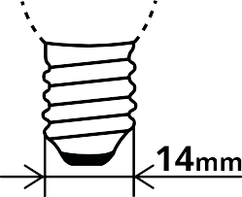  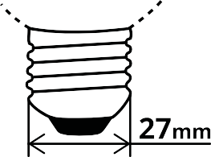  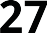 | Edison Screw type caps:  The number accompanying the cap type defines the diameter of the cap in mm  Fit – Screw in  E13 and E14 caps:  Commonly found in a range of domestic applications.  Many types of small light fittings around the home  from bedside table lamps to wall lights and chandeliers  Bulbs can come in many shapes such as golf ball shape, candle (chandelier) shape, Pygmy shape, and traditional bulb (ball) shape.  E 26 and E27 cap:  This is the most popular Edison screw caps and is found in vast range of applications.  E26 and E27 are often interchangeable and both are called (Medium) Edison Screw. (Abbreviated as MES or simply ES). Often called one-inch Edison Screw.
E14
E26
E27
BA15d |  | Bayonet type (B) bases with double contacts (d)  The number accompanying the cap type defines the diameter of the cap in mm.
B15d
B22d
GU10 |  | Lamps with a GU10 and GZ10 lamp base have two pins at the bottom of the lamp. These lamps are locked into the lamp base with a 90 degrees clockwise twist.  The difference between GU10 and GZ10 lamps lies in the bottom side. GU10 bulbs have a rounded bottom, while a GZ10 bulb has straight lines. As a result, a GU10 lamp fits both in a GU10 as in a GZ10 fitting, while a GZ10 only fits in a GZ10 fitting. Hence the letter ‘u’ – which stands for ‘universal’ – in its name.
GZ10

LAMP TYPE | ILLUSTRATION | REMARKS
G4 | 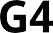 | Fit: Push in  e.g. Halogen capsule 12V, 16W G4
GY6.35 |  | Fit: Push in  Bi pin cap with 1.25 mm diameter pins. Distance between the centres of the two pins is 6.3 mm  Uses include low voltage display applications
GU4 | 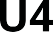 | Fit: Push in  GU model has the rounded cap whereas GZ cap has a square cap. GU cap fits onto GZ fitting but the GZ cap does not fit into the GU fitting.  GU4 - Used in spot lighting; both halogen and LED
GZ4
GU 5.3 | 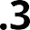 | Fit: Push in  Used in spot lighting; both halogen and LED Distance between centres of the two pins is 5.3mm GX cap does not have a grove across the base as GU
GX 5.3
G53 | 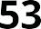 | G53 is a cap most often found on halogen and LED AR111 and PAR36 light bulbs. Light bulbs with G53 base types are typically used in retail, hospitality, and other commercial settings in fixtures with a G53 terminal connector.  Dimmable options available.

Low Voltage Base Fittings

(GU5.3 base) (GU4 base) (G4 base) (G53 base)

Mains Voltage Base Fittings (240V)
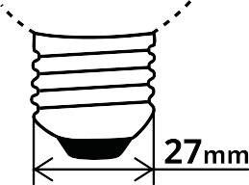
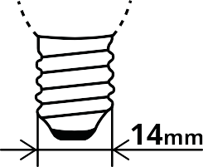

Small Bayonet (B15 / SBC)
Bayonet (B22 / BC)
Edison Screw (E27 / ES)
Small Edison Screw (E14 / SES)
GU10

Diagrams of cap types LED in scope for LED lamps
Table 7. Pictures of LED caps in scope

LAMP TYPE | BASE | REMARKS
BA15d |  | Bayonet type (B) bases with double contacts (d)  The number accompanying the cap type defines the diameter of the cap in mm.
B15d
B22d
E13 | 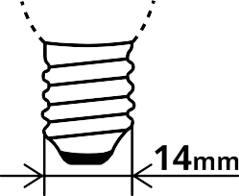  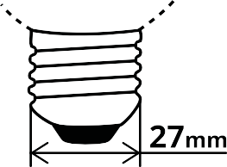  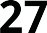 | Edison Screw type caps  The number accompanying the cap type defines the diameter of the cap in mm  Fit – Screw in
E14
E26
E27
E39
E40

LAMP TYPE | BASE | REMARKS
GU10 |  | Lamps with a GU10 and GZ10 lamp base have two pins at the bottom of the lamp. These lamps are locked into the lamp base with a 90 degrees clockwise twist.  The difference between GU10 and GZ10 lamps lies in the bottom side. GU10 bulbs have a rounded bottom, while a GZ10 bulb has straight lines. As a result, a GU10 lamp fits both in a GU10 as in a GZ10 fitting, while a GZ10 only fits in a GZ10 fitting. Hence the letter ‘u’ – which stands for ‘universal’ – in its name.  GX cap does not have a grove across the base as GU
GZ10
GX10
G4 | 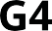 | Fit: Push in  e.g. Halogen capsule 12V, 16W G4
GU4 | 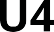 | Fit: Push in  GU model has the rounded cap whereas GZ cap has a square cap. GU cap fits onto GZ fitting but the GZ cap does not fit into the GU fitting.  GU4 - Used in spot lighting; both halogen and LED
GZ4
GU5.3 | 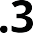 | Fit: Push in  Used in spot lighting; both halogen and LED Distance between centres of the two pins is 5.3mm
GY6.35 |  | Fit: Push in  Bi pin cap with 1.25 mm diameter pins. Distance between the centres of the two pins is 6.3 mm  Uses include low voltage display applications

LAMP TYPE | BASE | REMARKS
G53 | 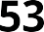 | G53 is a cap most often found on halogen and LED AR111 and PAR36 light bulbs. Light bulbs with G53 base types are typically used in retail, hospitality, and other commercial settings in fixtures with a G53 terminal connector. Dimmable options available.
GX53 | 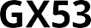
GU24 |  | Bi pin U type base with the distance between centres of the pins is 24mm
G9 |  | Bi –pin lamp with a special type pin

GEMS level requirements for Incandescent lamps

E1. Energy use and greenhouse gas production
The comparison of initial efficacy requirement applicable to product classes in the current and proposed Determinations is given in the Table 8.

Table 8. Initial efficacy requirements for product classes

PROPOSED DETERMINATION | CURRENT DETERMINATION (2016)
Product class 1  Mean value of initial efficacy ≥ 1  0.24 + 0.0103  √L | Product classes 1, 3, 4, 5 and 6 Mean value of initial efficacy  ≥ 2.8 × ln L – 4.0
Product class 2  Mean value of initial efficacy  ≥ 2.8 × lnL — 4.0 | Product class 2  Mean value of initial efficacy  ≥ 0.95 x (2.8 × ln L – 4.0)
Product class 7
Mean value of initial efficacy
≥ 2.8 × ln L – 4.0
where L is the mean measured initial luminous flux of the products in lumens.
Table 9 specifies testing requirements, in order to determine whether products meet the above requirements.

Table 9. Testing requirements

PROPOSED DETERMINATION | CURRENT DETERMINATION (2016)
Product tests must be conducted in accordance with the requirements mentioned in section 2 of AS/NZS 4934.1:2014 | Product tests must be conducted in accordance with the requirements mentioned in section 2 of AS/NZS 4934.1:2014
A test report must show conformance to AS 4934.2:2021 in accordance with AS/NZS 4934.1:2014 for each model tested. The test report must contain the applicable information mentioned in Appendix A of AS 4934.2:2021 | No specific mention on the format of the test report
Test measurements must only be recorded following the required duration for ageing, which is 100 ±1 hours  unless the lamp manufacturer specifies a lesser duration.  Lamps that fail prior to 100 hours must not be included in the mean and must be replaced with another lamp. | The required duration for ageing is 100 hours.  Lamps that fail prior to 100 hours must not be included in the calculation of the mean.
The minimum sample size is 10 units. | The minimum sample size is 10 units.
The proposed Determination specifies the format of the test report whereas the current Determination (2016) does not specify the format of the test report.

E2. GEMS labelling requirements for Incandescent lamps
Both the current and previous Determinations pertaining to Incandescent lamps require following information marked on all lamp packaging
    - Light output in lumens
    - Power in watts
    - Median life: rounded to nearest 100 h.
(In the current Determination (2016), the medium life is worded as the ‘Average lamp lifetime’)

Testing requirements: In order to determine whether products included meet the above requirements
Both Determinations prescribe that tests for the products identified in all categories must be conducted in accordance with the requirements mentioned in section 2 of AS/NZS 4934.1:2014

E3. Other GEMS requirements
Both Determinations prescribe the following conditions for all the product types,
- Lumen maintenance factor (when measured at 75% of rated median life, the mean lumen maintenance factor must be at least 80%)
- Median life (minimum 2000 hours)
In addition, the proposed Determination prescribes:
- Products in product class 2 must satisfy the maximum wattage requirements mentioned in clause 2.6 of AS 4934.2:2021.
Whereas the current Determination (2016) prescribes:
- For subsection 24(2)and paragraph 27 (1) (b) of the Act, the specified requirements relating to the performance of the product in product class 7 are,
  - The requirements mentioned in the Table 1 of subsection 8(1) and
  - The maximum wattage requirements in the clause 4.4 of AS4934.2-2011

Testing requirements: In order to determine whether products included meet the above requirements
Both Determinations prescribe that tests for the products identified in all categories must be conducted in accordance with the requirements mentioned in section 2 of AS/NZS 4934.1:2014.
In addition, the proposed Determination prescribes the following requirements as well.
- lamps that fail prior to 75% of rated median life must not be included in the calculated mean.
- The minimum sample sizes required for testing are,
  - for lumen maintenance factor—10;
  - for minimum median life—20;
  - for maximum wattage—10.

Ecodesign requirements—energy efficiency

Minimum required efficacy of an LED lamp
- The efficacy of an LED lamp (ηlamp) must not be less than the minimum required efficacy ηlamp.min (in lm/W)
What is Efficacy of a lamp? This is calculated by dividing the total light output of the lamp by its total power consumption. The units are lumens per watt (lm/W). The higher the efficacy value, the more energy-efficient the lighting product.
Why is it included? This criterion is of highest importance for the consumer and society to save energy and money.
- The minimum required efficacy is a function of the luminous flux Φ (in lm) and the colour rendering index R (-), as follows:
where:
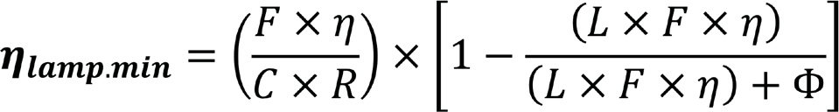

η, the threshold efficacy, is 120 lm/W.
L, the end loss factor, is 2.0 W for a Connected LED Lamp (CLL) and 1.5 W otherwise.
C, the correction factor, is defined in subsection
F, the efficacy factor, is:
  - for non-directional LED lamps (NDLL, using total flux)—1.00; and
  - for directional LED lamps (DLL):
    - using flux in a cone with an angle of 90° or 120°—0.85; or
    - using measurement of forward-facing lumens (corresponding to a cone with an angle of 180°)—as follows:

BEAM ANGLE (BA) | F VALUE
0 < BA < 90 | 0.95
90 ≤ BA < 120 | 1.00
R, the CRI factor, is (CRI+80)/160 for CRI ≥ 70, with both R and CRI rounded to two decimal places.
- For subsection (2), the correction factor for an LED lamp is the sum of:
  - the basic C value for the relevant type of lamp; and
  - each applicable additional C value; as given by the following Table 10:

Table 10. Correction factor

CORRECTION FACTOR C FOR AN LED LAMP
LED lamp type | Basic C value
Non-directional (NDLL) not operating on mains (NMLL) | 1.00
Non-directional (NDLL) operating on mains (MLL) | 1.08
Directional (DLL) not operating on mains (NMLL) | 1.15
Directional (DLL) operating on mains (ML) | 1.23
Special LED lamp features | Additional C value
Colour-tuneable LED lamp | +0.10
Directional (DLL) with anti-glare shield | +0.2
High-luminance LED lamps (HLLL) (not applicable to a DLL) | +0.0058 x Luminance - HLLL - 0.0167

- The efficacy of an LED lamp is the efficacy as measured in the reference control settings, where:
  - the lamp allows the end user to adapt the spectrum or the beam angle of the emitted light; and
  - the adaptation mentioned in paragraph (a) has the effect of changing:
    - the values for useful luminous flux, colour rendering index (CRI) or correlated colour temperature (CCT); or
    - the directional/non-directional status of the LED lamp.

Maximum standby power and networked standby power
- The standby power (Psb) of an LED lamp must not exceed 0.5 W
- The networked standby power (Pnet) of a connected LED lamp must not exceed 0.5 W
Note: Subsections (5) and (6) impose separate requirements that must each be complied with. For example, an LED lamp with a standby power of 0.2 W and a networked standby power of 0.7 W would not comply with these requirements on the basis that those values, added together, fall within a combined allowance of 1 W.
What is Standby Power (and Networked Standby Power)? This applies to the default (factory setting) mode of smart lamps (with any software updates) and other modes that provide a lighting control function which is not triggered via a communication network, (for networked Standby Power is triggered via a communication network) and which remain ‘on’ when emitting no light.
Why is it included? As integrated wireless, sensor control or communication protocols of lighting products expands in the market, this criterion is important for the consumer and society so as to ensure minimal additional power consumption associated with new lighting control features, importantly while the product is not producing light

LED lighting requirements

Information to be displayed on LED lamp packaging
- the model identifier; and
- the bar code number (if any)
- The rated useful luminous flux (Φuse), displayed in a font no smaller than the display of the rated on-mode power (Pon)
- If an incandescent or halogen lamp equivalence is claimed—the rated incandescent or halogen power equivalence
- The rated luminous efficacy, expressed in lumens per watt
- Either:
  - the rated correlated colour temperature, rounded to the nearest 100 K; or
  - the range of rated correlated colour temperatures that can be set (expressed in K)
- For a directional LED lamp:
  - the rated beam angle in degrees; or
  - the range of rated beam angles that can be set (expressed in degrees)
- Voltage and cap type
- The rated L70B50 lifetime, expressed in hours
- The rated on-mode power (Pon) expressed in watts to the first decimal place
- Unless the value is zero—the rated standby power (Psb), expressed in watts and rounded to the second decimal place
- Unless the value is zero—the rated networked standby power (Pnet) for a CLL, expressed in watts and rounded to the second decimal place
- Either:
  - the rated general colour rendering index, Ra, rounded to the nearest integer; or
  - the range of rated CRI-values that can be set (rounded to the nearest integers

- If the CRI is < 80, and the LED lamp is intended for use in outdoor applications, industrial applications or other applications for which applicable lighting standards specifically provide an allowance of CRI < 80—a clear indication to this effect
- Where the LED lamp cannot be dimmed, or can be dimmed only with specific dimmers or specific wired or wireless dimming methods:
  - a warning to that effect; and
  - where the LED lamp can only be dimmed with specific dimmers or dimming methods—details of where a list of compatible dimmers or dimming methods can be found

Information to be displayed on the LED lamp itself
- The rated value and physical unit of the useful luminous flux (lm)
- The correlated colour temperature (expressed in K) of the lamp; and
- For a directional LED lamp—the rated beam angle (expressed in °).
If there is insufficient room on the surface to include all of the values required without unduly obstructing the light emission:
  - if there is room for one value, the rated useful luminous flux must be displayed; and
  - if there is room for two values, the rated useful luminous flux and correlated colour temperature must be displayed.

Photobiological hazard requirements for LED lamps

Table 11. Health requirements for LED lamps

ITEM | COLUMN 1 ATTRIBUTE | COLUMN 2  HEALTH REQUIREMENTS
1 | Flicker | PstLM must be ≤ 1.0 at full-load.
2 | Stroboscopic effect for MLL | The SVM must be ≤ 0.9 at full-load.  However, there is no SVM requirement for lamps with all of the following characteristics:  - cap types E40 or E27;  - initial luminous flux > 2,000 lumens;  - the capacity to operate on control gear designed for high intensity discharge lamps.
3 | UV and Blue Light hazards | For LED lamps of ≤ 50V a.c. r.m.s. or ≤120 V ripple-free d.c,:  - the UV hazard must be RG0; and  - the Blue Light hazard must be either RG0 or RG1 unlimited.
What is Photobiological risk? Groups are defined in IEC 62471, with additional information given in IEC TR 62778 for blue light and UV hazard. The criterion sets a limit to the blue light and UV doses that the retina can receive.
Why is it here? - This criterion is important for consumer safety. High doses of blue light can cause irreparable damage to eyesight. Products need to be evaluated to determine their appropriate photobiological risk group.
What is Short term flicker ? Pst LM. This quantifies the likelihood of perception of a visual unsteadiness caused by cyclical variations in light output (both in total luminous flux or in chromatic characteristics) viewed as fluctuating brightness and/or colour perception by a stationary observer of a static environment (i.e. no movement by either).
Why is it here? As well as being distracting and annoying flicker, temporal light modulation at the same frequency range can produce photosensitive seizures amongst susceptible people. Limiting exposure to these risks is important to people’s health. Limitation on Pst LM levels can assist in this endeavour.

What is Stroboscopic Effect Visibility Measure (SVM)?. This quantifies the likelihood of perceived change in motion caused by cyclical variations in light output (both in total luminous flux or in chromatic characteristics) as viewed by a stationary observer of a non-static environment (i.e. moving object).
Why is it here - Under most lighting conditions, stroboscopic effect is undesirable. It is a source of distraction and may modify task performance. Setting an upper limit on SVM is therefore necessary to avoid the negative impacts of this effect.
UV hazard test is not required if the LED lamp does not contain an LED chip with a peak wavelength emission of less than 400 nm.
Blue Light hazard testing is not required if:
- the blue light hazard weighted radiance, LB, is < 10,000 W.m-2.sr-1 (as defined in clause 4.3.3 of AS/NZS 62471); or
- the maximum luminance of the visible light-emitting surface of the LED lamp does not exceed the limit specified in the Table 12 below.
Note that SVM is not applicable to the stroboscopic effects observed on moving machines and tools.

Table 12. Maximum luminance limits

MAXIMUM CCT (K) | MAXIMUM LUMINANCE  (Mcd.m-2)
CCT ≤ 2,350 | 40.0
2,350 < CCT ≤ 2,850 | 18.5
2,850 < CCT ≤ 3,250 | 14.5
3,250 < CCT ≤ 3,750 | 11.0
3,750 < CCT ≤ 4,500 | 8.5
4,500 < CCT ≤ 5,750 | 6.6
5,750 < CCT ≤ 8,000 | 5.0
Manufacturer’s rated CCT and rated luminance may be used as a basis for this assessment.

Note: Further testing is not required if the true luminance (in the direction of maximum intensity) of the LED lamp;
- is less than 10 000 cd/m2, it is classified RG0,
- complies with the following values for the given correlated colour temperatures (CCT) its classification will be RG0 or RG1.

Background on the Greenhouse and Energy Minimum Standards Act 2012
The Equipment Energy Efficiency (E3) program is an initiative of the Australian Government, states and territories and the New Zealand Government. These groups combined to deliver a single, integrated program on energy efficiency standards and labelling for equipment and appliances.
E3 was established by the former Council of Australian Governments (COAG) Energy Council and now continues under Energy Ministers through the Energy Ministers’ Meeting (EMM). An Inter-Governmental Agreement provides the
framework for national cooperation on the E3 Program. Further information is available at https://www.energyrating.gov. au/about.
On 1 October 2012, the Greenhouse and Energy Minimum Standards (GEMS) Act 2012 came into effect, creating a national legislative framework for product energy efficiency in Australia. This Act promotes the development and adoption of products that use less energy and produce fewer greenhouse gases.
The specific requirements for each product regulated under the GEMS Act—including Minimum Energy Performance Standards (MEPS) and Energy Rating Labelling (ERL)— are set out in legislative instruments specific to that product type, called a GEMS Determination. GEMS determinations cover different product classes. They can specify requirements for the amount of energy used by operating products in the product class, greenhouse gas production, labelling and some other matters, including the impact of products on the environment or human health.
Before making a GEMS determination, the responsible Minister must obtain consent to the terms of the determination from jurisdictions.
With the introduction of the Act, the GEMS Regulator (located in the Department of Climate Change, Energy, the Environment and Water) replaced the previous state regulators for equipment energy efficiency.

Caveats on ABS lighting
ABS lighting related categories include over 20 luminaire classes and 45 lamp classes. However, these are poor at classifying LEDs as they were originally developed for older lighting technologies. Analysis of the data suggests that there is a level of uncertainty concerning the accuracy of the declaration of LED products in the correct class. This is especially highlighted in the number of imports that are declared as ‘other’. This uncertainty needs to be taken into consideration when considering the detailed data classifications. For example:
- 2020 luminaire imports: 39.2 million luminaire items out of a total of 80.4 million luminaire imports were listed in the ‘other’ luminaire category;
- 2020 LED lamps imports: 22 .5 million out of a total of 30.9 million LED lamp imports were classified as a basic LED lamp with no details,
- An additional 11.3 million non-LED lamp products were also classified as ‘other’ (thus total 33.8 million ‘other’ out of 67 million lamps).
- LED imports were not captured before 2017.
In order to try to improve the accuracy of import declarations the department has drafted a guide to the lighting import categories. However we have delayed release of this guide until after the updated import categories are released,
at which point the guide will be updated to align with the new categories. Further uncertainty results from:
- An unknown number of the LED products are imported as part of State Government white certificate schemes, which is not part of the mainstream market.
- Several product categories (such as downlights and linear lamps) overlap between residential, commercial and retail sectors, making it difficult to know where changes are occurring.
- Note also that the 2021 data in the charts below has been arrived at by doubling the Jan-June 2021 data. Monthly and even annual lighting imports are known to be a bit ‘lumpy’, thus this projection for 2021 has a higher uncertainty.
- Detailed data for LED lighting only became available from 2017.

Public Consultation Paper: Investigating future regulatory options for lighting products
December 2022
www.energyrating.gov.au

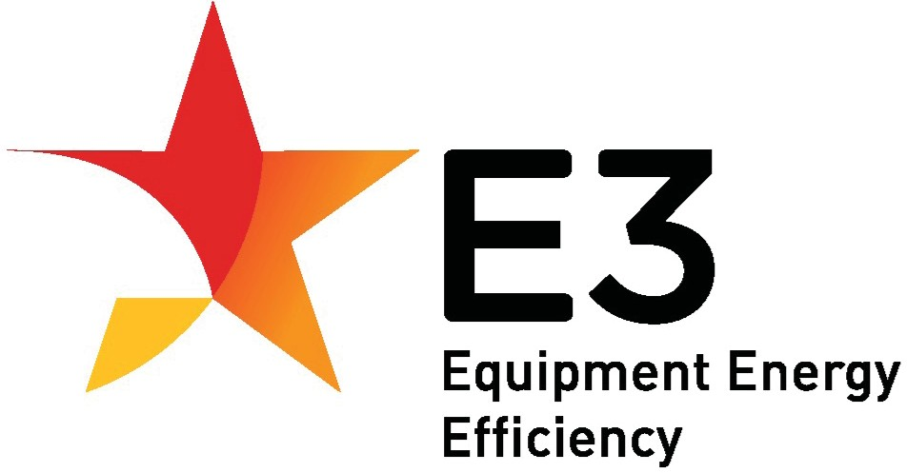

A joint initiative of Australian, State and Territory and New Zealand Governments

